
Year 11 Essentials

Mini Test 1.4

Volume and Capacity
Name:________________

Resources to be provided by the student: Calculator, a single sided A4 page of notes, ruler, pens, pencils  Time: 20min |  | Total: /18  Weighting: 1%

- [4 marks]
Choose an appropriate unit of measurement to describe the volume of the following items.
a) | Refrigerator | b) | Moving box

c) | Takeaway food container | d) | Car

- [4 marks]
Calculate the volume of the following 3D objects

a) A cube with edges of length 5cm b)

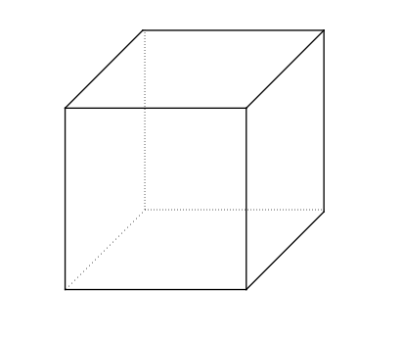
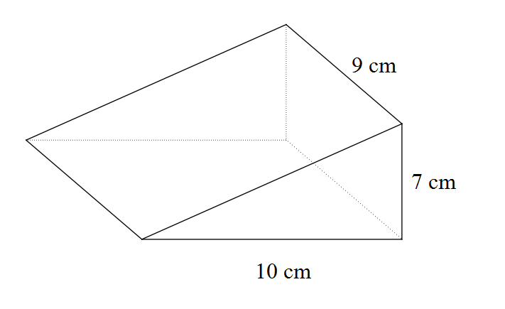

- [4 marks]
Determine the capacity of the objects in Question 2 in millilitres and litres.

- [6 marks]
A fish tank has rectangular sides made of glass. It is 120 cm long and 70 cm wide. The water is 42 cm deep.

- Sketch a diagram depicting this information.
- How many cubic centimeters of water does the fish tank contain?
- If each litre of water occupies 1000 cm³, how many litres does the tank contain?

